Solar analysis report
Project whatever

Introduction:
Unlikely to change very much, will add some deterministic outcomes below about the findings at high level.
A bit of context about the site, and some other information.

Methodology:
I would usually include an image of test model and screen and elaborate on them here, will add once study finishes.
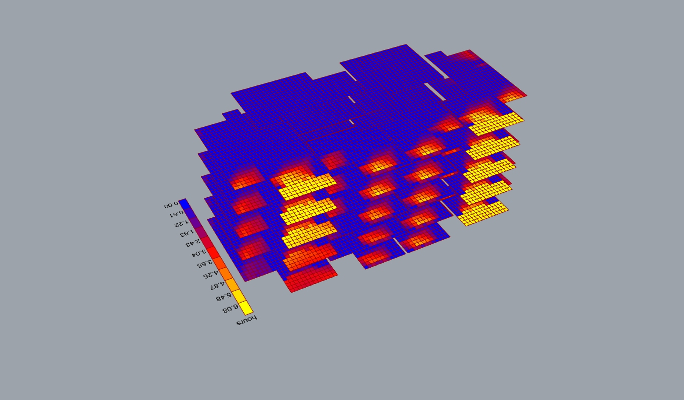
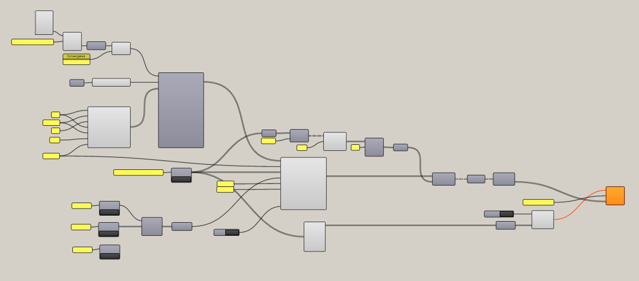
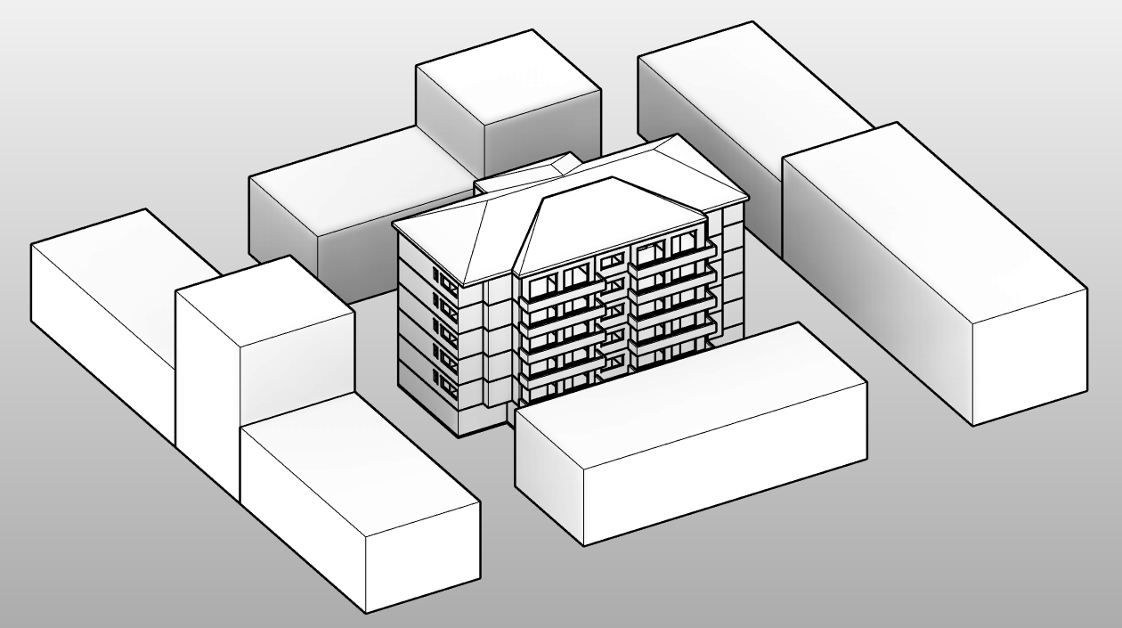

Results:
Images and summaries of the outcomes, probably a revit schedule or two.
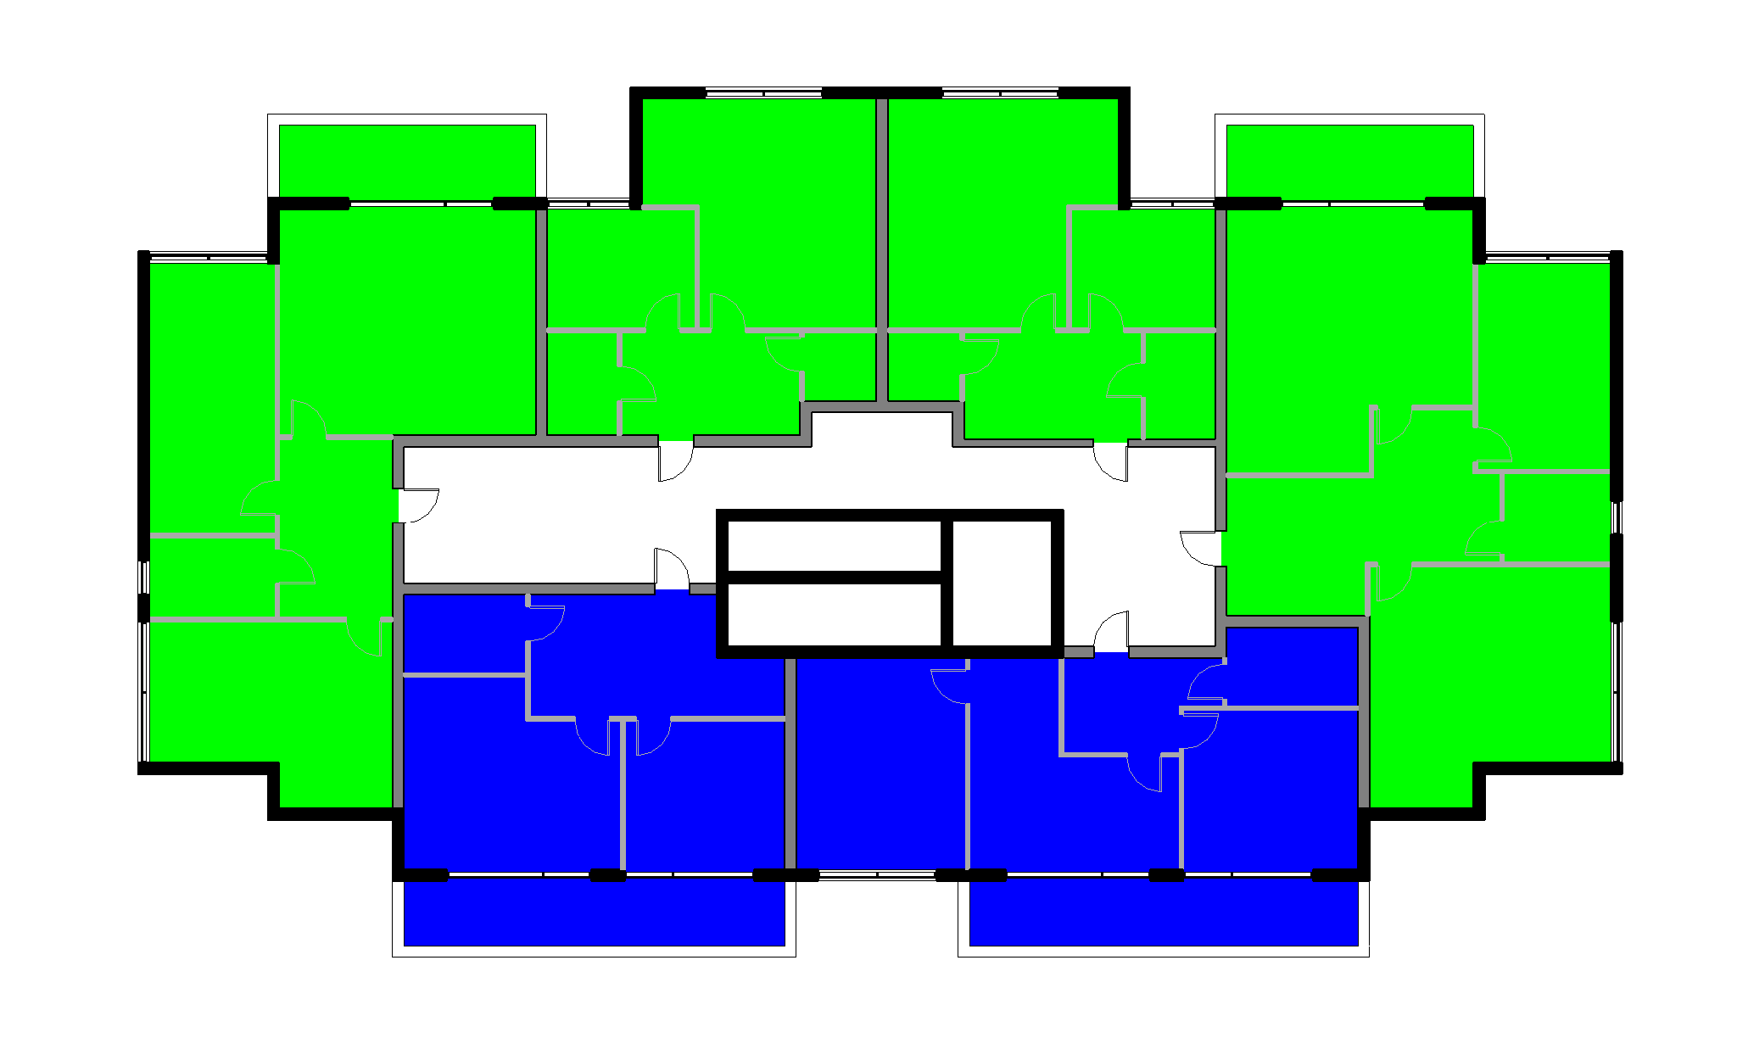
Above: Level 1 compliance


Above: Level 2 compliance

Above: Level 3 compliance

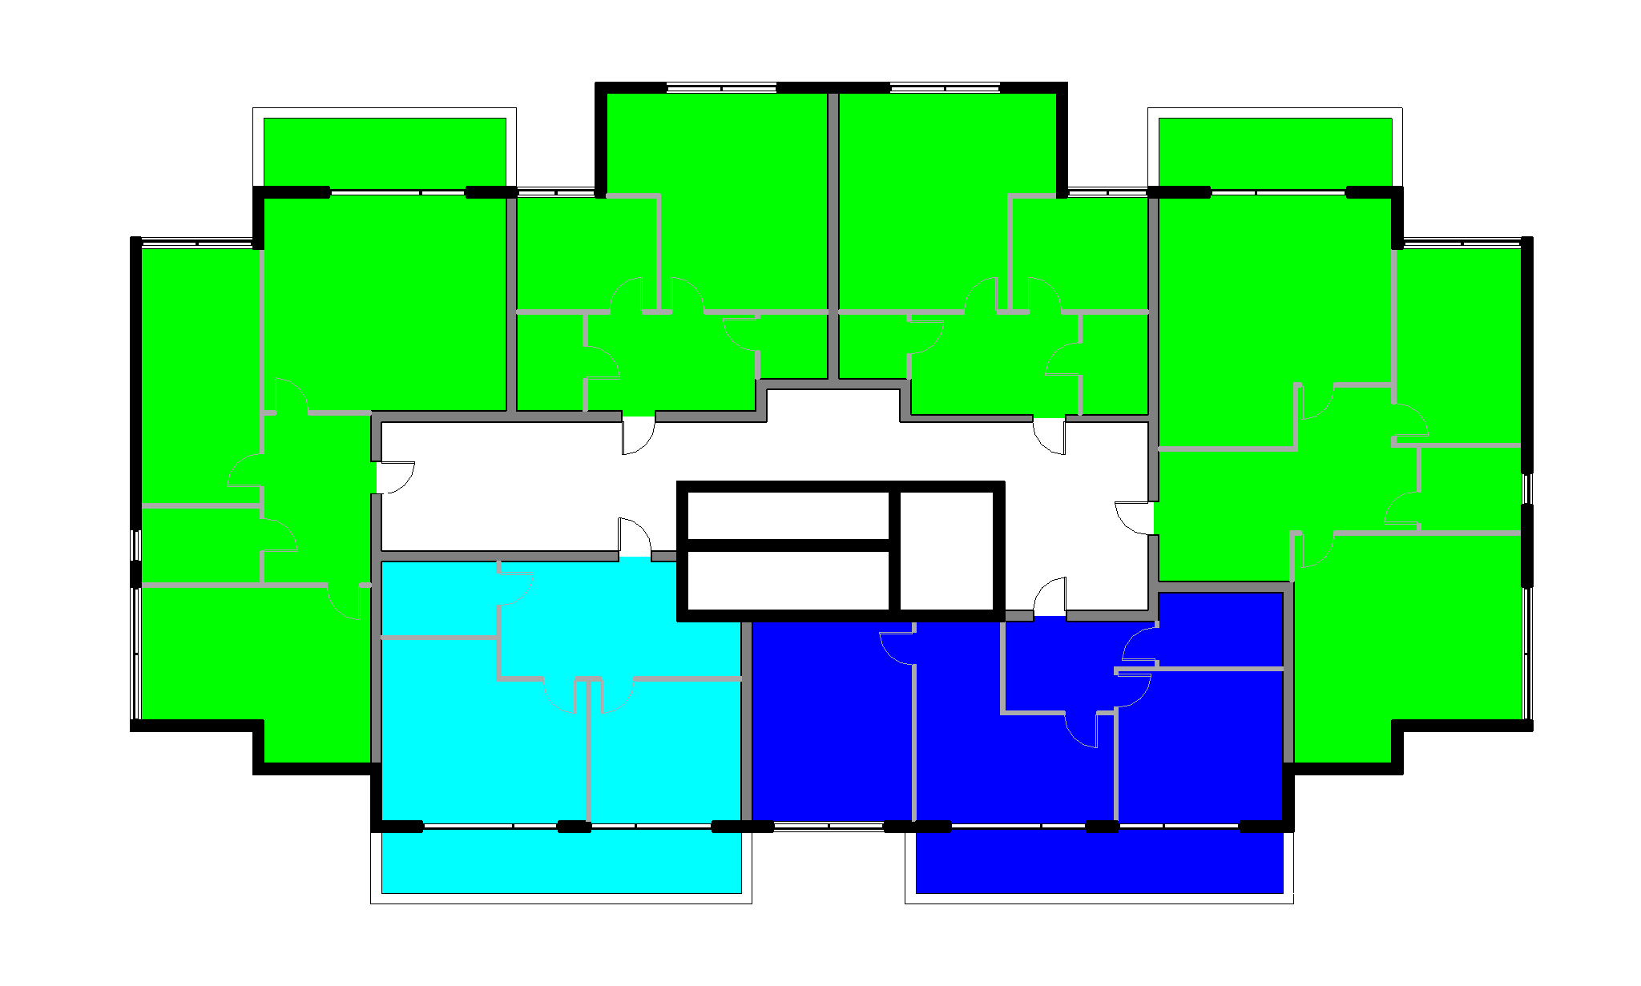
Above: Level 4 compliance
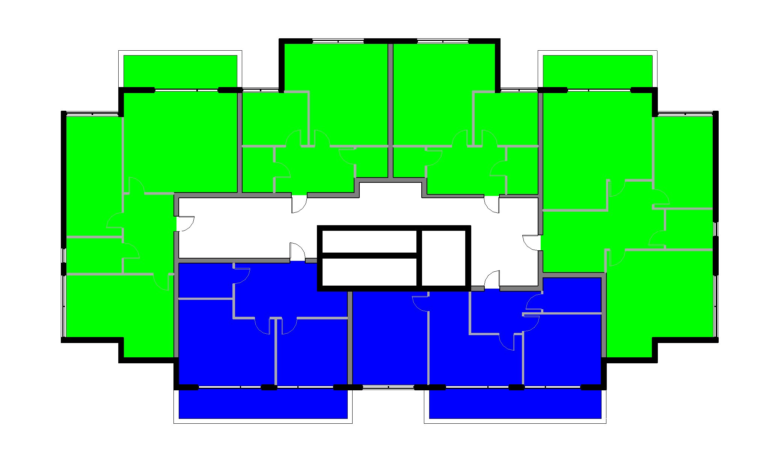
Above: Level 5 compliance

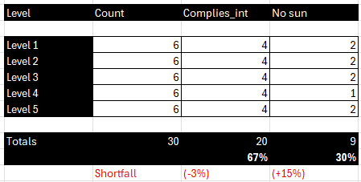
Above: Table of findings

Conclusion:
In conclusion your building does not comply and you should feel bad. Good thing the council doesn’t understand the requirements anyway!

